Conquering the Wave that No-one Dared to Surf
4 February 2015
BBC
Jeff Clark
http://www.bbc.com/news/magazine-31115858
(Slightly edited for classroom use)

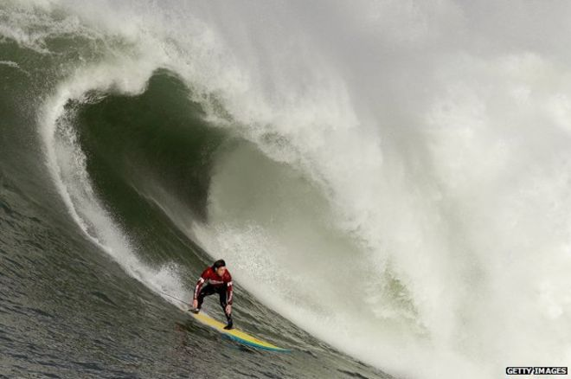
For years Jeff Clark used to go to Mavericks Beach to watch giant waves that appears after a winter storm. Then, one day in 1975, he decided to surf one. Here he describes that moment - and how two decades later Mavericks became one of the most famous (or infamous) surfing beaches in the world.

Those waves come from 1,000 miles away, and they're as big as a four-story building. Can you imagine a four-story building coming at you at 30 miles per hour (that’s 48 KM per hour) and all of a sudden, it hits the curb and topples over on top of you? That's what it's like at Mavericks.
You have to catch that wave and make it down the face of that wave before it trips and topples over and comes crashing down on you. It's one of the most exciting things I could ever think to do. I started to watch it and study it and eventually the day came where the conditions were perfect. It was plate glass. The waves were just rhythmic big peaks coming in.
When you're by yourself doing anything that's on the edge, you're very calculated, very careful. You don't do anything that you don't think you're going to make 99% of the time. I mean you just can't afford to make a mistake at that point. So you're patient. I started my paddle out, and I remember the current being very strong because the tide was full. And I had to paddle across this reef, and I just remember battling, battling through these waves. And finally I made it out to the line-up.
There are rocks about 500 yards (475m) off the beach that protrude out of the water. Out past those rocks, there are underwater shelves that are in the shape of your hand -- they look like a crocodile back on the ocean floor. And the tail curves up to the north-west. As a wave starts to feel that alligator tail it slows down a little bit, and as it gets toward the reef at Mavericks, it gets shallower and the middle part becomes wedge-shaped. That wedge all of a sudden hits a shelf that is only 15ft (4.5m) deep and it's like somebody tripping.
When the wave came, I turned and was totally committed -- head down, pulling water as hard as I could, paddling that board as fast as it could be paddled. I start to feel that acceleration down the face of the wave. I hit my feet, and as I start to drop, there is the shadow of that wave standing up behind me. And I'm just going down the face of that wave and cringing, trying to maintain speed to outrun this thing. And I made it. I got away. And there was nothing more satisfying than to see something for so many years, watch it, study it and then to actually go out and accomplish what you thought you could do. But nobody else was up for surfing it. I drove around for years trying to bend people's ears -- just short of dragging them out there. And they wanted no part of it.
Then in 1990, I was able to get two guys to paddle out with me from Santa Cruz, and they went back to Santa Cruz with this tale of this big wave. The next time Mavericks broke, there were 12 guys all ready to charge it and that changed everything.
It was a little disconcerting early on. But as the people came and went and they tried and they failed and they tried and they succeeded, it kind of sorted itself out. And the appreciation went back to the wave -- that nobody's going to come and overtake this wave. And that was the consoling thing with sharing it. It was still going to be Mavericks, and it will take care of itself.
In December 1994, I heard that Mark Foo, Ken Bradshaw, and Brock Little were coming to surf Mavericks. I paddled out and went surfing and finally they paddled out to the line-up. It was big and really good, but it wasn't giant and out of control. Not stop-you-in-your-tracks big. It was very approachable 25-to-30ft faces.
I paddled up to Mark and I said, "Mark, what do you think?" and he said, "I never imagined there were waves this good." I was just so stoked to hear that.
Later, I was changing on the beach, and a guy yelled at me from the cliff, "Hey Jeff, there's a lot of guys in the water going into the rocks." I grabbed my binoculars and it looked like everybody made it through fine.
I went to talk to the guys at the harbor master's office. Right at that point, a mayday came over the loudspeaker in the harbor. The harbor patrol pulled up, and the two guys start working on somebody. And then we realized it was Mark Foo. They worked on him and were unable to resuscitate him. He was one of the guys in that group getting washed through the rocks. He never came up and nobody noticed.
I said, "I've got to go to the point and get Ken Bradshaw who Mark came with." So I drove out to the point and I finally ran into Ken. 'Ken, you need to come with me," I said. "Mark drowned." He said, "Take me to him." It was a pretty sad day.
Mark had said, you know you have to be willing to pay the ultimate price for the ultimate thrill. And unfortunately it did cost him his life. I did feel responsible. We knew Mavericks was dangerous. We knew that it could take us. If it was our time to go, it was going to take us.
Two days later, on Christmas day, I grab my board, my wetsuit. I drive out to the point, and there's no-one there. I kind of hang around, getting my stuff together, and nobody shows up. I walk out to the end of the point, get on my knees, say a prayer. I talk to my maker about the events that had happened and ask Him to watch over me.
And just before I jump off the rocks, I hear this hoot and holler from the top of the cliff. It's my friends who I have surfed with since high school. They'd seen my car parked, they walked out, saw my backpack, and they found me getting ready to get in the water. I was just like, "Yes! So cool." I paddle out and take a moment for Mark once I get out into the peak. I start riding waves, and I ride the last wave all the way into the lagoon. That was, for me, a kind of fitting closure. It's still a tragedy.
It kind of changed everything. Nobody had really died in big-wave surfing for years and now one of the best from Hawaii comes to California and dies surfing big waves. And the reality and the realization that surfing big waves is dangerous and you can die became first and foremost. To have three boats in the water, a helicopter, jet skis and nobody kept track of the surfers in the line-up… I was blown away.
I ended up starting Mavericks water patrol and we started to get all the surfers trained in water rescue and lifesaving techniques, CPR -- just to cover us, just so that we could take care of our own.
Mavericks got its name from a dog that these surfers had in the early 1960s. They surfed inside the rocks at Mavericks and the dog would paddle out, and they'd have to take it back to the beach. And they ended up calling the waves Mavericks. Today, it's known as the best pure paddle-in surf spot that there is.
The infamy of Mavericks made it, I think, more popular than ever. To survive and surf Mavericks, you would have to cheat death. I wasn't a big fan of all that notoriety and the reputation that Mavericks could kill you. I was more concerned about staying alive and making sure my friends stayed alive.
So it's been 40 years of surfing Mavericks. And to see the influx of people that surf it, the careers that have been made surfing Mavericks -- it's kind of an amazing thing. I still really enjoy going out there. I wish I could go there with nobody out just a couple more times, but I know that that won't happen. But I pick and choose the days that I do go out there and surf. I surfed it a couple weeks ago, and it was still as amazing as the first time.

